ASSIGNMENT 4

Name: Avishkaar Pawar

Semester : 4th

Course : B.Sc (H) Computer Science

Roll No : AD-1224

Date-of-Submission : 07 April , 2023

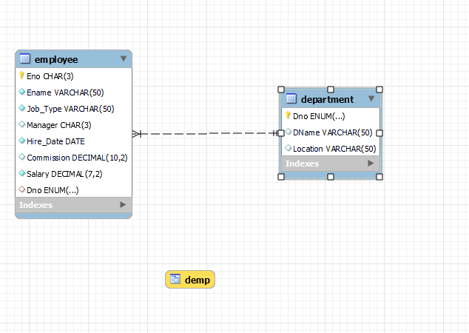

**/* DDL COMMANDS */**

create database EMP_DEPT;

use EMP_DEPT;

create table Department(

Dno enum('10','20','30','40','50') NOT NULL PRIMARY KEY,

DName varchar(50) DEFAULT NULL,

Location varchar(50) Default "New Delhi"

);

/*Foreign key references Employee(Eno)*/

create table Employee (

Eno char(3) NOT NULL primary key,

Ename Varchar(50) not null,

Job_Type varchar(50) not null,

Manager char(3) ,

Hire_Date date Not Null,

Commission Decimal(10,2),

Salary Decimal(7,2) Not Null,

Check (5000>Salary and Salary>1000),

Dno enum('10','20','30','40','50'),

foreign key (Dno) references Department(Dno)

);

**QUERIES**

/* Question 1

Query to display Employee Name, Job, Hire Date, Employee Number for each employee with the Employee Number appearing first */

**Select Eno, Ename,Job_Type,Hire_Date from employee;**

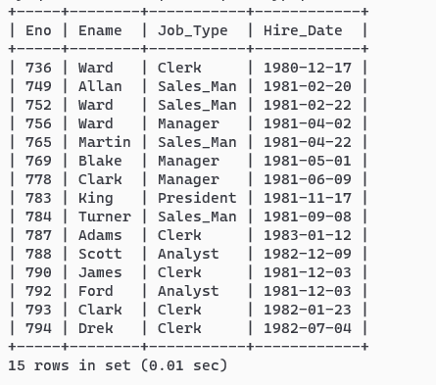

/* Question 2

Query to display Unique Jobs from the Employee Table. */

**select distinct job_type from employee;**

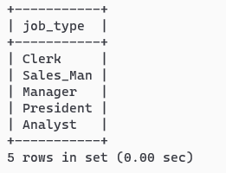

/* Question 3

Query to display the Employee Name concatenated by a Job separated by a comma.

*/

**select concat_ws(",",ename,job_type) from employee;**

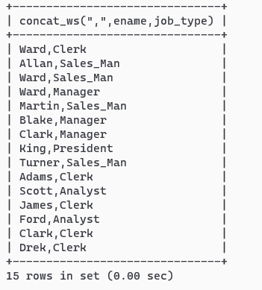

/* Question 4

Query to display all the data from the Employee Table. Separate each Column by a comma and name

the said column as THE_OUTPUT.

*/

**select concat_ws(" , ", eno, ename,job_type , manager, hire_date, commission,salary,dno) THE_OUTPUT from employee;**

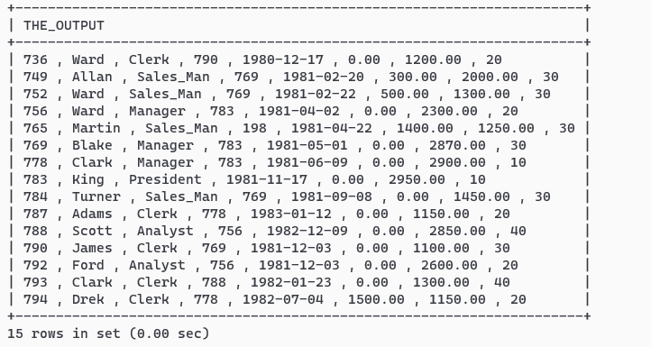

/* Question 5

Query to display the Employee Name & Salary of all the employees earning more than $2850.

*/

**select ename,salary from employee where salary>2850;**

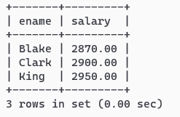

/*Question 6

Query to display Employee Name & Department Number for the Employee No= 790

*/

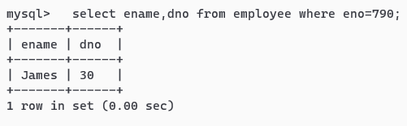

**/*Question 7**

**Query to display Employee Name & Salary for all employees whose salary is not in**

**the range of $1500 and $2850.**

**\*/**

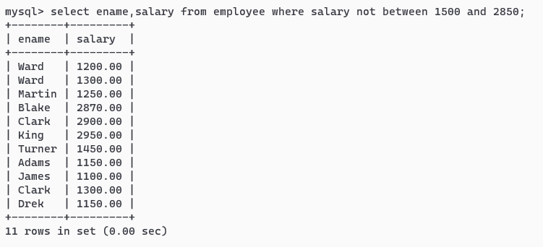

**/*Question 8**

**Query to display Employee Name, Job, and Hire Date of all the employees hired between Feb 20,**

**1981 and May 1, 1981. Order the query in ascending order of Start Date.**

**\*/**

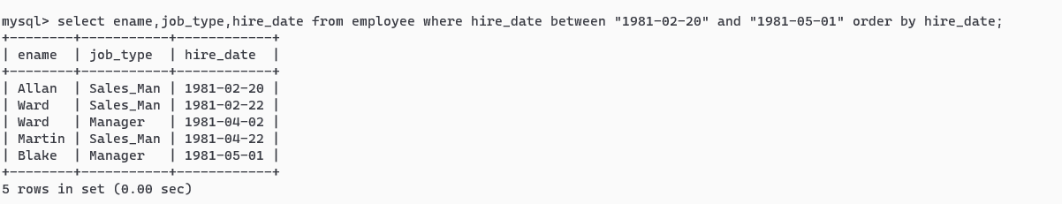

**/* Question 9**

**Query to display Employee Name & Department No. of all the employees in Dept 10 and Dept 30 in**

**the alphabetical order by name.**

**\*/**

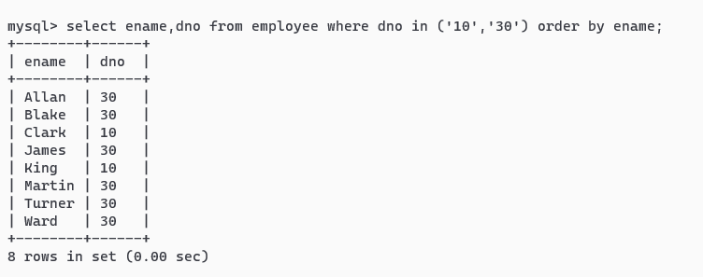

**/* Question 10**

**Query to display Employee Name & Salary of employees who earned more than $1500 and are in**

**Department 10 or 30.**

**\*/**

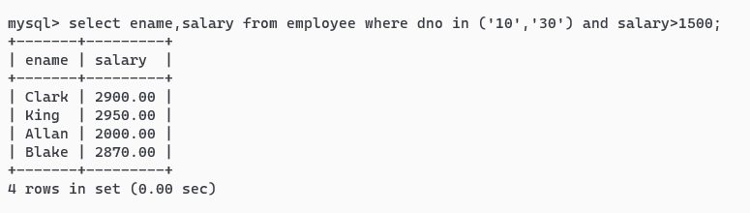

**/* Question 11**

**Query to display Name & Hire Date of every Employee who was hired after 1981.**

**\*/**

select ename,hire_date from employee where year(hire_date)>1981;

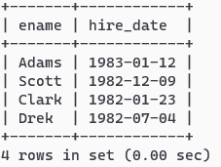

**/* Question 12**

**Query to display Name & Job of all employees who don’t have a current Manager.**

**\*/**

select * from employee where Manager is NULL;

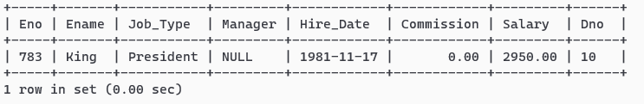

**/* Question 13**

**Query to display the Name, Salary & Commission for all the employees who earn commission. Sort**

**the data in descending order of Salary and Commission.**

**\*/**

select ename,salary,commission from employee where commission!=0 order by salary desc,commission desc;

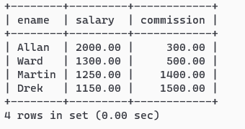

**/* Question 14**

**Query to display Name of all the employees where the third letter of their name is ‘A’ and job type is**

**manager.**

**\*/**

select ename from employee where ename like "__A%" and job_type="Manager";

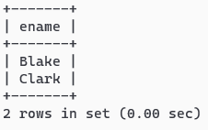

**/* Question 15**

**Query to display Name of all employees either have two ‘R’s or have two ‘A’s in their name & are**

**either in Dept No = 30 or their Manger’s Employee No = 778.**

**\*/**

select ename from employee where ename like "%a%a%" or ename like "%r%r%" and dno="30" and Manager=778;

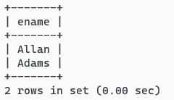

**/* Question 16**

**Query to display Name, Job and Salary of all employees whose Job is Clerical or Analyst & their**

**salaries are not equal to 1000, 3000, or 5000.**

**\*/**

select ename,job_type,salary from employee where job_type="Clerical" or job_type="Analyst" and salary not in (1000,3000,5000);

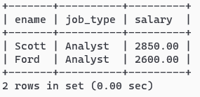

**/* Question 17**

**Query to display Name, Salary and Commission for all employees whose Commission Amount is**

**greater than their Salary increased by 5 %**

**\*/**

select ename,salary,commission from employee where commission>(1.05)*salary;

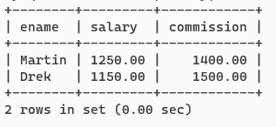

**/* Question 18**

**Query to display the Current Date and the last date on which any employee joined.**

**\*/**

select curdate , max(hire_Date) from employee;

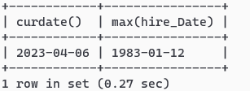

**/* Question 19**

**Query to display Employee No., Name, Salary and the Salary increased by 15 % expressed as a**

**absolute whole number.**

**\*/**

select eno,ename,salary , FORMAT((salary*1.15),0) "115% SALARY" from employee;

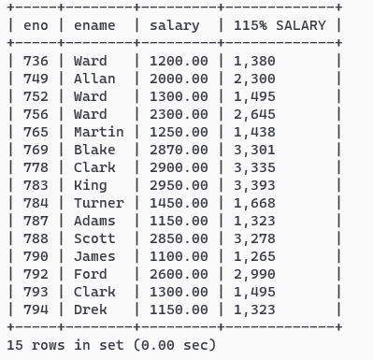

**/* QUESTION 20**

**Query to display Name, Hire Date and Salary Review Date which is the 1st Monday after six months of employment.**

**\*/**

select ename, hire_date,

CASE

WHEN dayname(hire_date+ INTERVAL 6 MONTH)='MONDAY' THEN hire_date+ INTERVAL 6 MONTH

WHEN dayname(hire_date+ INTERVAL 6 MONTH)='TUESDAY'THEN DATE_ADD(hire_date+ INTERVAL 6 MONTH,interval 6 DAY)

WHEN dayname(hire_date+ INTERVAL 6 MONTH)='WEDNESDAY' THEN DATE_ADD(hire_date+ INTERVAL 6 MONTH,interval 5 DAY)

WHEN dayname(hire_date+ INTERVAL 6 MONTH)='THURSDAY' THEN DATE_ADD(hire_date+ INTERVAL 6 MONTH,interval 4 DAY)

WHEN dayname(hire_date+ INTERVAL 6 MONTH)='FRIDAY' THEN DATE_ADD(hire_date+ INTERVAL 6 MONTH,interval 3 DAY)

WHEN dayname(hire_date+ INTERVAL 6 MONTH)='SATURDAY' THEN DATE_ADD(hire_date+ INTERVAL 6 MONTH,interval 2 DAY)

WHEN dayname(hire_date+ INTERVAL 6 MONTH)='SUNDAY' THEN DATE_ADD(hire_date+ INTERVAL 6 MONTH,interval 1 DAY)

END

AS SALARY_REVIEW_DATE

from employee;

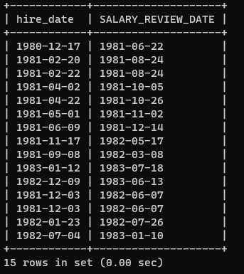

**/*Question 21**

**Query to display the employees that earns a salary that is higher than the salary of any of the clerks**

**along with the difference in salary.**

**\*/**

Select ename,salary from employee where salary>(select max(salary) from employee where job_type="Clerk");

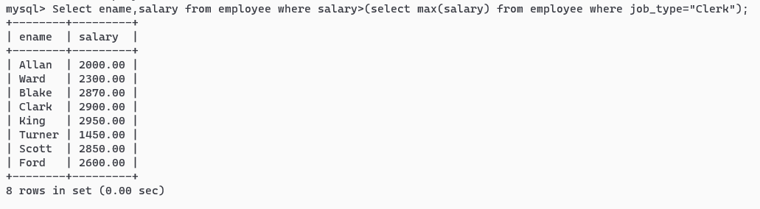

**/* Question 22**

**Query to display Name and calculate the number of months between today and the date each**

**employee was hired.**

**\*/**

select eno,(year(curdate())-year(hire_date))*12+(month(curdate())-month(hire_date)) Month_Diff from employee;

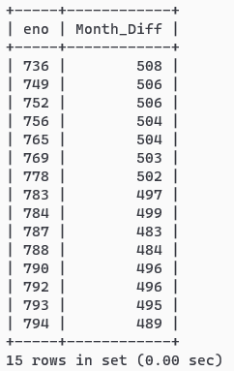

**/* Question 23**

**Query to display the following for each employee:- <E-Name> earns < Salary> monthly but wants < 3**

**\* Current Salary >. Label the Column as Dream Salary**

**\*/**

select concat(ename," earns ",salary," monthly but wants ",3*salary) "Dream Salary" from employee;

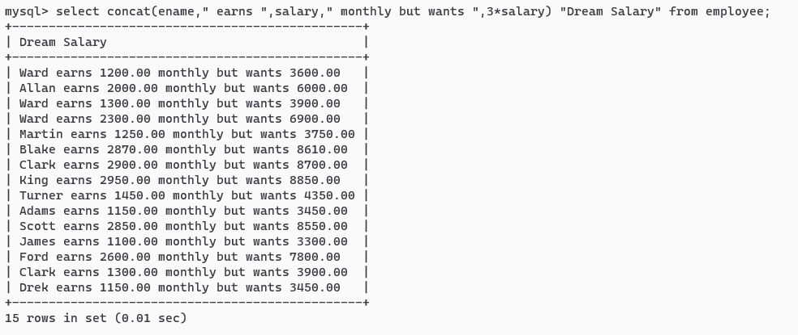

**/* Question 24**

**Query to display Name and Salary for all employees. Format the salary to be 15 character long, left**

**padded with $ sign.**

**\*/**

select lpad(salary,15,"$") from employee;

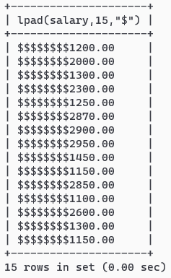

**/* Question 25**

**Query to display Name with the 1st letter capitalized and all other letter lower case & length of their**

**name of all the employees whose name starts with ‘J’,’A’ and ‘M**

**\*/**

select concat(left(ename,1),substring(ename,2)) as Name from employee where ename like "J%" or ename like "A%" or ename like "M%" ;

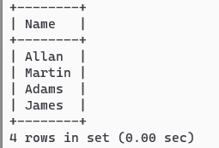

**/* Question 26**

**Query to display Name, Hire Date and Day of the week on which the employee started his/her job**

**\*/**

select ename , hire_date , dayofweek(hire_date) DayOfWeek from employee;

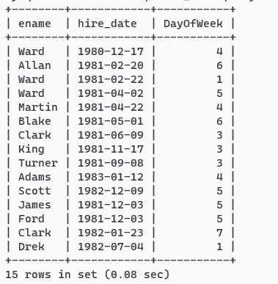

**/* Question 27**

**Query to display Name and Commission Amount. If the employee does not earn commission then**

**use default value ‘No Commission’.**

**\*/**

select ename,if(commission>0,commission,"No Commission") from employee;

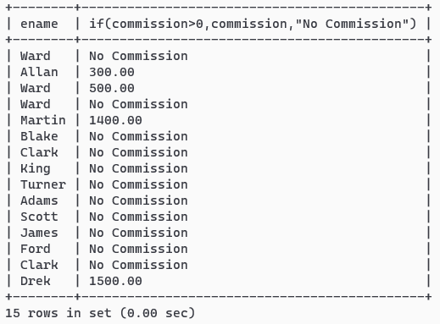

**/* Question 28**

**Query to display Name, Department Name and Department No for all the employees.**

**\*/**

select ename , dname ,dno from employee natural join department;

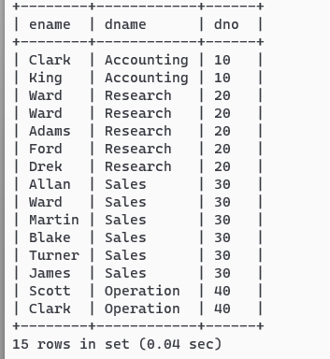

**/* Question 29**

**Query to display Unique Listing of all Jobs that are in Department # 30**

**\*/**

select distinct job_type from employee where dno="30";

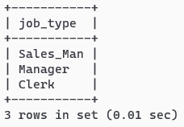

**/* Question 30**

**Query to display Name, Department Name and Location for all employees earning a commission**

**\*/**

select ename,dname,location from employee natural join department where commission>0;

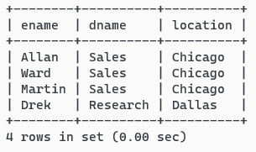

**/* Question 31**

**Query to display Name, Dept Name of all employees who have an ‘A’ in their name and works at**

**user-specified location.**

**\*/**

set @location=#EnterLoc;

"chicago";

select ename,dname from employee natural join department where (ename like "%A%") and location=@location;

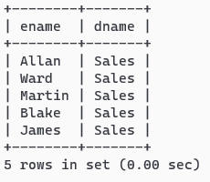

**/* Question 32**

**Query to display Name, Job, Department No. and Department Name for all the employees working**

**at the Dallas location.**

**\*/**

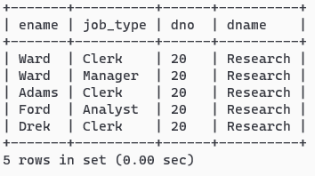

**/* Question 33**

**Query to display Name and Employee No. along with their Manager’s Name and Manager’s**

**employee no. */**

select A.eno,A.ename,A.manager,B.ename "Manager's Name" from employee A , employee B where A.manager=B.eno;

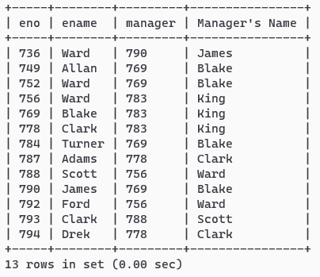

**/* Question 34**

**Query to display Name and Employee no. along with their Manger’s Name and the Manager’s**

**employee no; along with the Employees’ Name who do not have a Manager**

**\*/**

select A.eno,A.ename,A.manager,B.ename "Manager's Name" from employee A left join employee B on A.manager=B.eno or A.manager=NULL;

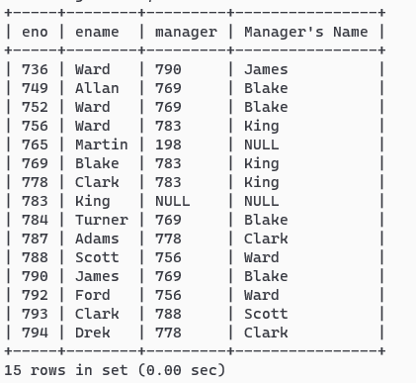

**/* Question 35**

**Query to display the Employee No, Name and Salary for all employees who earn than the average**

**salary and who work in a Department with any employee with a ‘T’ in his/her name.**

**\*/**

select eno,ename,salary from employee where (salary >(select avg(salary) from employee)) and (dno =any(select dno from employee where ename like "%t%"));

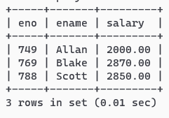

**/* Question 36**

**Query to display Name, Dept No. & Salary of any employee whose department No. and salary**

**matches both the department no. and the salary of any employee who earns a commission.**

**\*/**

select A.ename,A.dno,A.salary from employee A,employee B where B.dno=A.dno and A.salary=B.salary and B.commission>0 and A.commission=0;

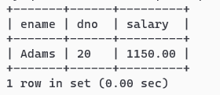

**/* Question 37**

**Query to display Name, Hire Date of any employee hired after the employee Blake was hired by the**

**Company**

**Assuming there is only one Blake**

**\*/**

select ename,hire_date from employee where hire_date>(select hire_date from employee where ename="Blake");

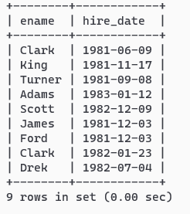

**/* Question 38**

**Query to display Name and Hire Dates of all Employees along with their Manager’s Name and Hire**

**Date for all the employees who were hired before their managers**

**\*/**

select A.ename,A.hire_date,B.ename,B.hire_date from employee A, employee B where A.hire_date<B.hire_date and a.manager=b.eno;

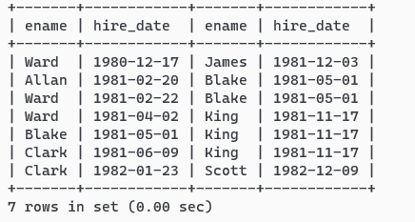

**/*Question 39**

**Query to display Name and Salaries represented by Asteristisks – “Each asterisks (*) signifying $100.**

**\*/**

select ename,repeat("*",salary/100) from employee;

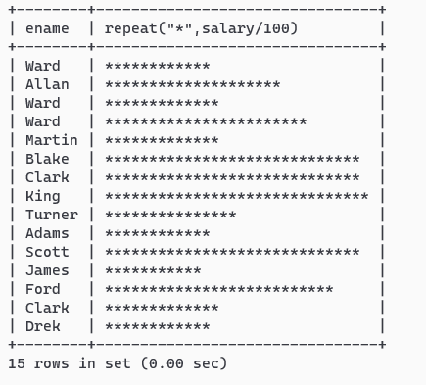

**/* Question 40**

**Query to display the Highest, Lowest, Sum and Average Salaries of all the employees**

**\*/**

select max(salary) Highest, min(salary) Lowest , sum(Salary) Sum , avg(salary) Average from employee;

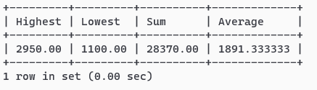

**/* Question 41**

**Query to display Highest, Lowest, Sum and Average Salary for each unique Job Type**

**\*/**

select job_type,max(salary) Highest, min(salary) Lowest , sum(Salary) Sum , avg(salary) Average from employee group by job_type;

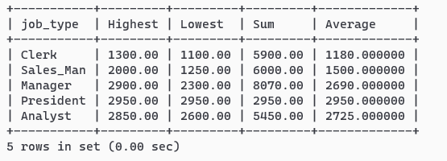

**/* Question 42**

**Query to display the number of employees performing the same Job type functions**

**\*/**

select count(*),job_type from employee group by job_type;

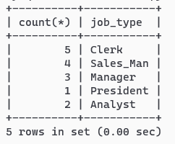

**/* Question 43**

**Query to display the no. of managers without listing their names.**

**\*/**

select count(distinct manager) from employee;

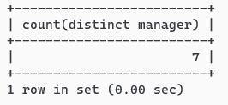

**/* Question 44**

**Query to display the Difference between the Highest and Lowest Salaries for each department**

**\*/**

select max(salary)-min(salary) from employee group by dno;

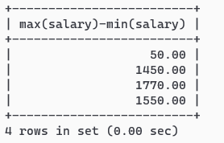

**/* Question 45**

**Query to display the Manager’s No. & the Salary of the Lowest paid employee for that respective**

**manager. Exclude anyone where the Manager ID is not known. Exclude any groups where the minimum**

**salary is less than $1000.**

**\*/**

select manager,min(salary) from employee group by manager having manager is not null and min(salary)>1000;

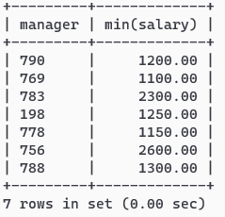

**/* Question 46**

**Query to display the Department Name, Location Name, No. of Employees & the average salary for**

**all employees in that department.**

**\*/**

select D.dno,location,count(eno),avg(salary) from employee E , department D where E.dno=D.dno group by D.dno;

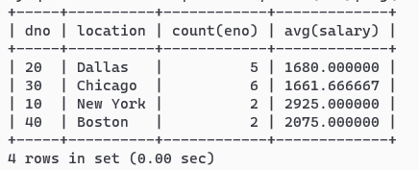

**/* Question 47**

**Query to display Name and Hire Date for all employees who work in the same dept. as Blake.**

**\*/**

select ename, hire_date from employee where dno=(select dno from employee where ename="Blake");

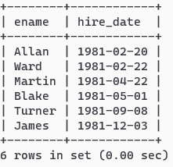

**/* Question 48**

**Query to display the Employee No. & Name for all employees who earn more than the average**

**salary in their respective department**

**\*/**

select A.eno,A.ename,A.salary,B.salary from employee A, (select avg(salary) Salary,dno from employee group by dno ) B where A.salary>B.salary and a.dno=b.dno;

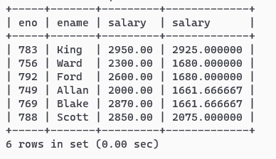

**/* Question 49**

**Query to display Employee Number & Name for all employees who work in a department with any**

**employee whose name contains a ‘T’.**

**\*/**

select eno,ename from employee where dno in (select dno from employee where ename like "%t%");

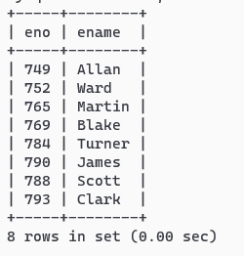

**/* Question 50**

**Query to display the employee name and salary of all employees who report to King.**

**\*/**

select ename , salary from employee where manager=(select eno from employee where ename="King");

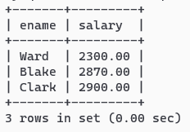

**/* Question 51**

**Query to display the Department No, Name & Job for top-5 employees (as per salary earned) in the**

**Sales Dept on descending order on name**

**\*/**

select dno , ename, job_type, salary from employee where dno=(select dno from department where dname="Sales") order by salary desc LIMIT 5;

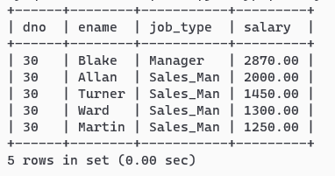

**/* Question 52**

**Select manager name getting salary greater than average salary of employees in his department.**

**\*/**

select distinct b.ename , b.salary , c.salary Avg_Salary from employee A , employee B, (select avg(salary) salary,dno from employee group by dno ) C where a.manager=b.eno and b.dno=c.dno and b.salary>c.salary ;

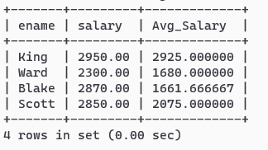

**/* Question 53**

**Create a view to store following information:**

**Dname| Location |Average salary| Number of Employee|Date of joining of first employee**

**\*/**

create view Demp as

select Dname,Location,b.salary Average_Salary, b.count "Number of Employee",b.hire_date "Date of joining of first employee"

from (select avg(salary) salary,dno,min(hire_date) hire_date,count(*) count from employee group by dno) B,

Department D where b.dno=d.dno ;

